About Dr. Moshe Feldenkrais

Dr. Moshe Feldenkrais, a physicist, engineer and judo master, pioneered a learning system that utilizes movement and awareness of self to bring about remarkable changes in the human mind and body. Dr. Feldenkrais was born in Russia in 1904. He left home at age twelve and immigrated to then Palestine. He supported himself during his high school years as a construction worker and as a tutor to failing students. He developed great interest in hypnosis and autosuggestion; learned and taught self-defense techniques; played soccer and was a weight lifter. In his early twenties he moved to Paris, France where he first earned a degree in Mechanical and Electrical Engineering. He continued to earn his Doctor of Science degree in Physics, doing pioneering nuclear research with Joliot-Curie.
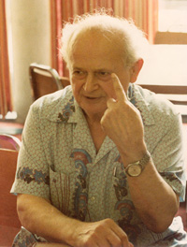
Dr. Feldenkrais

While in Paris, he met Professor Kano, the creator of modern Judo and the Minister of Education of Japan at the time. Professor Kano chose Dr. Feldenkrais to be trained in his art and subsequently open the first Judo club in Paris. During the same years, he joined his wife, a medical student, in studying with her all of her courses.

During World War Two, as the Germans were entering Paris, Dr. Feldenkrais escaped to England, where he was recruited by the British Admiralty to serve as a scientific officer. When he suffered a debilitating knee injury, he realized that surgery would not give him a good enough outcome. Instead he began exploring ways to re-educate his brain to move in new ways that work, despite the damage to his knee.
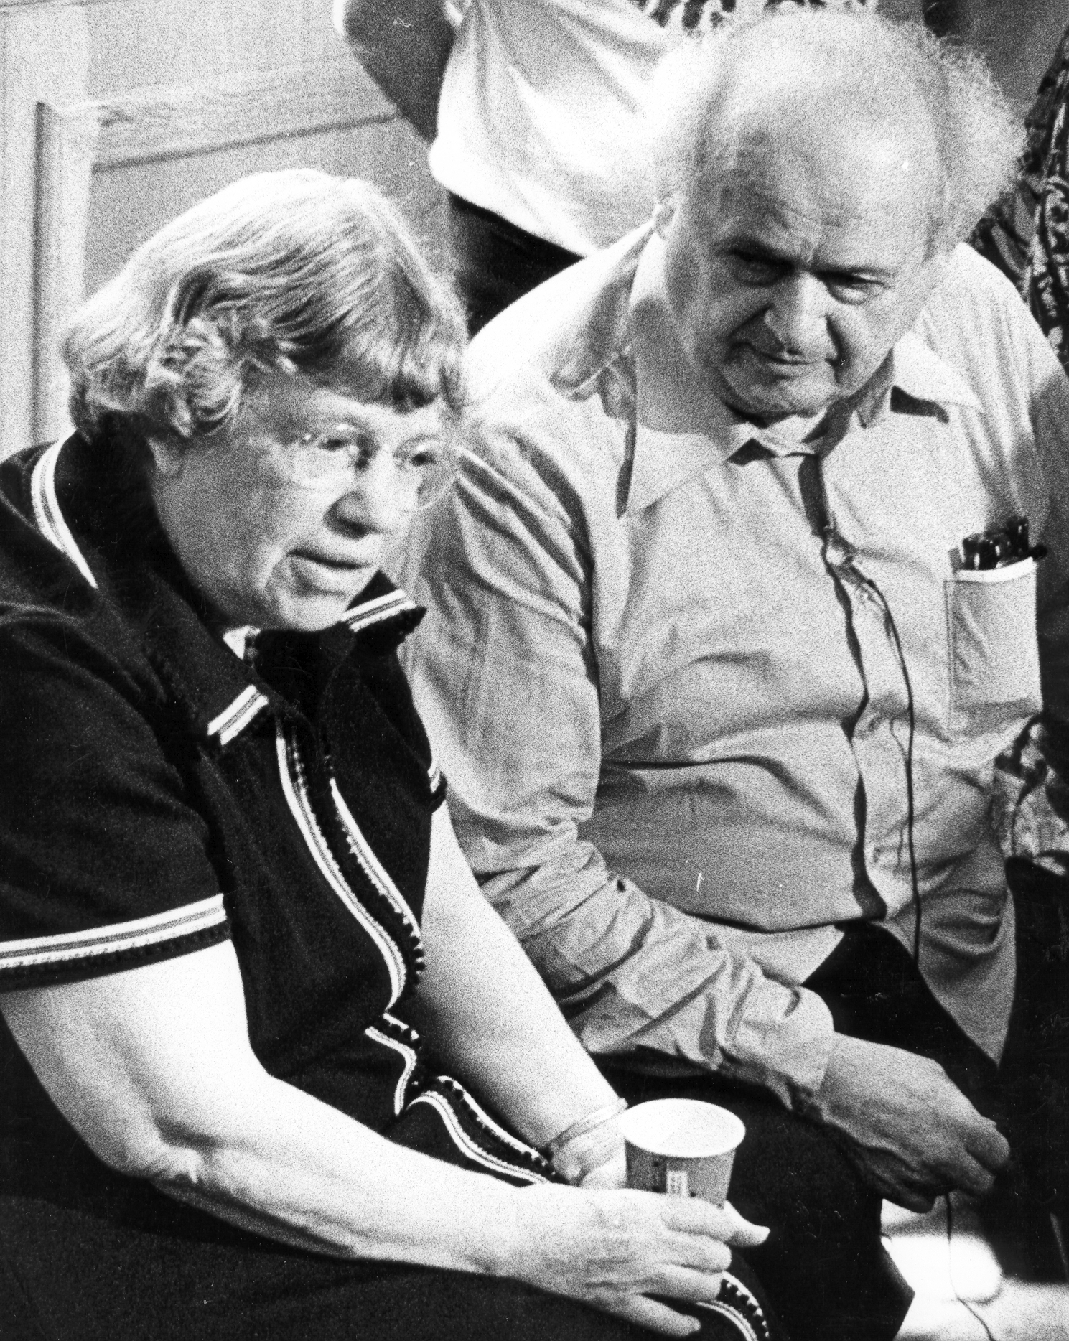
Dr. Feldenkrais with
Margaret Mead
He recovered full functioning and at the same
time developed a scientifically based new method.
He created hundreds of movement lessons and
personalized hands on teaching, based on his
understanding of the central nervous system,
making it possible for the brain to organize action
more effectively; helping people learn throughout
life; and consistently make the impossible possible
for them.

In the early 1950s he left his position as the head
of the Missile Research Unit for the Israeli Army and
devoted his time fully to the continued development
of his method until his death in 1984.

"This is the most sophisticated and effective method I have
seen for the prevention and deterioration of function."
Margaret Mead, Ph.D.

About Anat Baniel
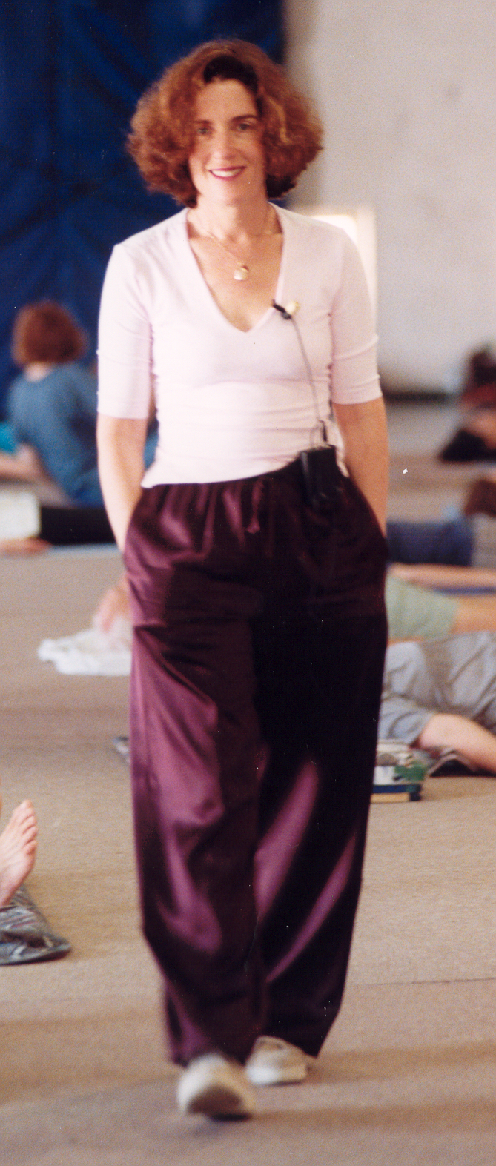
Anat Baniel

Ms. Baniel was born in Israel, to a scientist father, and a poet and garden architect mother. She went to graduate school in Tel-Aviv University to become a clinical psychologist. At the same time she pursued her passion for dance. She worked as a psychologist for the Israeli Army for a number of years.

While in Grad school, she began studying with Dr. Feldenkrais. After Graduating his training program in 1977, she began working full time as a teacher in this method.

While still living in Israel, Anat began teaching the work in the Jerusalem Academy of Music and Dance; taught for Dr. Feldenkrais in his Tel-Aviv institute and in his
professional training; and developed her own practice.

In 1982 Ms Baniel moved to New York City where she quickly developed a practice working with babies and young children; with musicians; with athletes and with adults suffering back pain, injury etc. She also began teaching seminars and professional training programs worldwide.

In 1986 she founded her own training organization and has been involved in training
over 1000 practitioners during her career. Between 1985 to 1989 she worked with the Tanglewood Music Center. She taught a program for the San Francisco Symphony musicians beginning in 1994 for over six years.

In private practice Ms. Baniel is renowned for her success working with small children and infants with developmental difficulties who she has helped to achieve goals never thought possible by their medical professionals.

She has helped world class musicians with repetitive motion injuries regain full and active careers and helped athletes to overcome injuries and reach new levels of performance. Through her work she has helped those with chronic pain and other
limitations regain full functioning. She has helped her many students, young and old,
regain vitality and the ability to pursue their dreams.

Through her 28 years experience working as a trainer, teacher and private practitioner, she evolved her original training into a new Method that combines the teachings of Dr. Feldenkrais with her own understanding and techniques to help others and train future practitioners to help their clients in amazing ways.

"You are a masterful teacher, the best I've ever had! You are very supportive in your approach. The conditions are fabulous to learn. Your work with children is magical. You are an extension of God's hands." -Ray Burns, PT, Anat Baniel Method for Children Practitioner, Feldenkrais Practitioner

About Anat Baniel and Dr. Moshe Feldenkrais
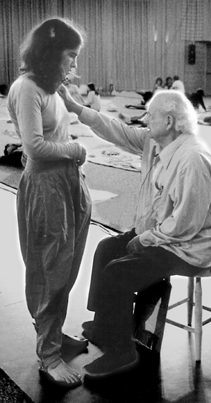
Anat Baniel and Dr. Feldenkrais
Ms. Baniel remembers meeting Dr. Feldenkrais for the first time as a very young child when he came to her parents’ home to teach his movement classes. At the time he was still heading the missile research unit for the Israeli Army. Anat’s father, a scientist himself, took great interest in Dr. Feldenkrais’s budding method and organized a group of scientist colleagues to participate in those weekly classes.

At age seven, Anat began studying with a Ballet teacher who herself was a student of Dr. Feldenkrais. She introduced his work and weaved it into her dance teaching. Till today Ms. Baniel remembers vividly her first encounter with Dr. Feldenkrais’s work. The changes she experienced in flexibility, in movement skill and in well-being were immediate and far reaching, like no other experience.

It was not until roughly 15 years later, when Ms. Baniel finished her undergraduate studies in Psychology and Statistics and was looking to find a way to work with people that included movement and the body, that she remembered her experiences with the Feldenkrais work.

While in graduate school in the Tel-Aviv University, she contacted Dr. Feldenkrais at his studio in Tel Aviv. She began taking private lessons from him. She observed him work with private clients as often as she could, while studying Clinical Psychology and working as a psychologist for the Israeli Army.

A year and a half later, in 1975, Dr. Feldenkrais opened a professional training program in San Francisco, which Ms. Baniel joined.

Soon after she graduated his program in 1977, Dr. Feldenkrais invited Ms. Baniel to work at his institute in Tel-Aviv. That was the beginning of the transformation of a student teacher relationship into a close professional relationship and a close friendship.
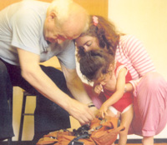
Dr. Feldenkrais and Anat Baniel
working with child

Ms. Baniel and Dr. Feldenkrais worked side by side in the
same room seeing clients. In 1978, when Dr. Feldenkrais
required assistance during his extensive world travel, he
asked Ms. Baniel to accompany him, which she did for as
long as he was able to travel.

During those years of travel, Ms. Baniel and Dr. Feldenkrais
spent many hours discussing his ideas and theory. Still in
her twenties, Ms Baniel got to see, hear and witness
hundreds of hours of Dr. Feldenkrais’ teaching in many

About Anat Baniel and Dr. Moshe Feldenkrais (cont'd)

different situations. She observed him work with world
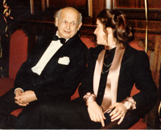
Anat Baniel and Dr. Feldenkrais
in Munich, Germany

class musicians, actors, authors, politicians, therapists,
businessmen and educators on the one hand, and with
ordinary people from different cultures and from all
walks of life. She assisted him in his work with large
groups in his seminars and in his training program.

Despite his huge stature, Dr. Feldenkrais was adamant
that Ms. Baniel do the work in her own distinct way,
allowing her work to develop and evolve uniquely and fully.

Ms. Baniel began teaching for Dr. Feldenkrais as trainer in
1980, working both together with him, and independently.

In 1981 Dr. Feldenkrais fell ill while in Zurich, Switzerland. He asked that Ms. Baniel come be with him to help take care of him and eventually bring him back home to Tel-Aviv.

Ms. Baniel and Dr. Feldenkrais remained close until his death in 1984.

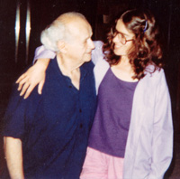
Anat Baniel and Dr. Feldenkrais
in Amherst, Massachusetts

"Anat’s teaching is exquisite. She willingly shares the intensive training she received from Dr. Feldenkrais with her students and we become transformed." -Marianne Kagan, Anat Baniel Method for Children Practitioner, Feldenkrais Practitioner

"Anat is a faithful practitioner of Moshe’s legacy, and at the same time an innovator, who enriched it by developing her own method." -Gideon Schwartz, Professor of Statistics

