A new approach to helping children with developmental challenges

Working with the Whole Body

By Anat Baniel and Naomi Ora Liebowitz

This article is about Grace R., a child with Brachial Plexus to her right arm and hand resulting from a birth injury.

When I first saw Grace at 13 months old, she was obviously a healthy child. At the same time the limitation in her right arm was apparent. She held her right arm close to her body with the elbow bent in a contracted manner. The fingers of the right hand had minimal movement and the wrist was contracted and rigid. She was able to hold objects by tucking them between her right forearm and chest, and she was able to transfer objects with her left hand into her right hand. Although she was able to stand up holding on, she was unable to crawl due to the fact that she was unable to straighten or lean on her right arm.
Dear Dr. James;
My daughter, Grace R., is a patient of yours in the brachial plexus clinic…I am writing to tell you about a particular form of work, The Anat Baniel Method for Children, Grace has been receiving for the past 13 months…(and) how profound this work is.
Before we began the Anat Baniel Method for Children, the difference between Grace’s two arms was becoming more noticeable, both in physical terms and what she was capable of doing developmentally. …(Since then) the changes in Grace have been amazing. After the first few sessions, Grace began crawling for the first time in her life…. It was as if her brain woke up and became aware of her right arm in a very different way. With this awakening came more movement, and more strength. Each time I have been concerned that she might never be able to do a certain movement, she showed me within a short period of time that she was totally capable of doing it. The latest breakthrough has been her ability to spontaneously reach back behind her head with her right arm, providing herself with active external rotation.
...If my Grace is any indication, this form of work will relieve much pain and suffering and stigma for brachial plexus children and their families.

Betsy G. (Grace’s mother)

When a child suffers from contractures, it is easy to think and feel that something is wrong with her muscles and look to bring about change through manipulation of the joints and the musculature in the affected area(s). Methods that use this approach include: range of motion and stretching exercises, braces, surgery, and Botox. All these interventions certainly have an impact on the child. However, our contention is that the only way to bring about maximum recovery, and often times any real recovery of function at all, is by performing the intervention in such a way that it will provide meaningful and useful information to the nervous system.
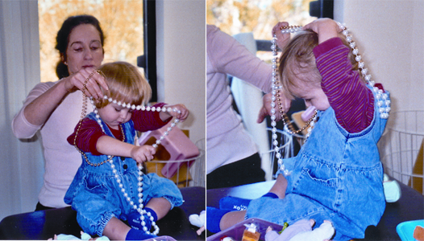

By the third lesson, Grace initiated putting a bead
necklace over her head using both hands.

Before beginning work in our method, Grace received a variety of therapies and daily range of motion exercises, with little progress. As in other approaches, we too touch and move the child, but we do not do so in an attempt to directly bring change to a specific joint or muscle group. We use movement and touch as a language, as a way of communicating with the nervous system of the child. We know that the brain is a highly complex, self-organizing system that organizes and controls movement. We look to provide the child with experiences (information) that would allow it to reorganize itself and bring about the desired changes spontaneously.

One way in which we provide meaningful information for the child’s brain is
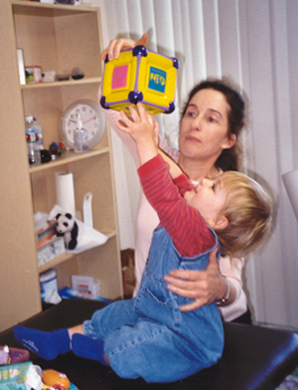
through the understanding that the body works as a dynamic whole. The arm
does not move in isolation, but is a part of the organization of the whole body.
When a healthy child lifts her arm to the front and above her head, for example,
we can observe movement in the shoulder, the head, the spine, the ribs, the
lower back (it arches), the chest (it lifts), the hip joints, the knees, and the feet
(you might want to try it for yourself to feel how it works).

The whole body has to organize itself to insure not only successful lifting of
the arm, but also maintaining of balance, orienting in space and maintaining
Anat Baniel
working with Grace
the continuity of movement. In Grace’s case, due to the substantial reduction
in the communication between her right arm and her brain, her ability to learn
to move that arm and the rest of her body in relation to it were greatly diminished.
Only a rudimentary image of that arm could form in her brain. When Grace’s arm
was lifted and moved about during range of motion exercises, her system had little recognition of the arm and its movements, hence there was little progress.

The first time I* worked with Grace I had her in her mother’s lap nursing.
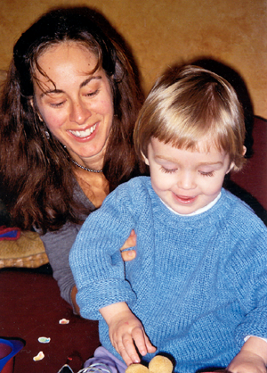
That provided her with a feeling of safety and gave me easy access to her back.
I began by touching her spine and felt that she was able to easily move it to the
left in the direction of her fully functioning arm. When I attempted to move the
spine to the right, it was rigid. Her head tilted easily to the left since she was
able to lean on the left hand, but could not tilt it to the right. Her right knee
tilted easily to the left with the right hip lifting as in side sitting, but her left
knee would not tilt to the right preventing her from falling as she was unable
to lean on the right hand.

In other words, Grace’s brain had actively organized her whole body to not use
Naomi Ora Liebowitz working with Grace.
or rely on her right arm.

This understanding provide us with a remarkable opportunity for transformation.

Instead of focusing on Grace’s paralyzed right arm, I turned my and Grace’s attention to the healthy parts of her body that could readily learn to move “as if” her right arm was fully functioning. I began very gently moving her spine, ribs, pelvis, legs and head in directions and ways she had never moved them before due to the injury to her right arm. Fifteen minutes into the first lesson Grace spontaneously lifted and extended her right arm forward. At home, without prompting, she continued to move her right arm, lifting, leaning and supporting herself with it. She also began walking from room to room and standing on her own for the first time. By the third lesson Grace initiated putting a bead necklace over her head using both hands.

As the lessons progressed, no matter which specific function of the arm and hand we were working on, we continued to use the whole body as an integral and often leading aspect in the process of Grace gaining new capabilities. Today, a year after we began working with Grace, her right hand has become the dominant one, and most of the time it is hard to tell the difference between the two arms, hands, and fingers. Grace’s right hand and arm are now an integrated part of her image of self, enabling her to move fully and in ways not previously possible for her.

*Anat Baniel gave Grace her first few lessons after which she and Naomi Ora have been sharing the work with Grace.

Previously published in Cerebral Palsy Magazine, September, 2003 and in
Outreach, the magazine of the United Brachial Plexus Network, November, 2003.

Copyright 2003, Anat Baniel MethodSM. All Rights Reserved.

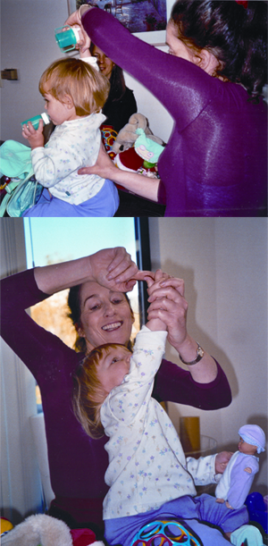

The arm does not move in isolation,
but is a part of the organization
of the whole body.
Excerpts from Grace’s first 12 lessons with Anat Baniel are available on DVD.
Also on the DVD are excerpts from lessons with two children with cerebral palsy.
Call (800) 386-1441 or email info@anatbanielmethod.com to order.

