A new approach to helping children with Cerebral Palsy and other brain related disorders.

By Anat Baniel
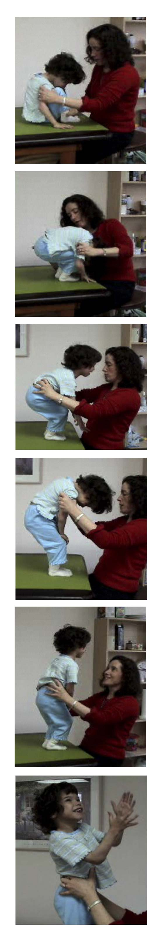

When a child has Cerebral Palsy or other brain related disorders, everyone’s goal is to help the child gain full functioning in movement, thought, perception and feeling. The question is how?

The Anat Baniel Method for Children proposes an approach that is fundamentally different from the existing therapeutic approaches both in theory and in technique. It consistently enhances the recovery of function in children with Cerebral Palsy well beyond the current norm.

In this article I present through the story of one child two examples of thinking and technique in the application of my method.

Grace was brought to me at three years old. She was born 11 weeks premature and is one of twins. A small built girl, she had severe CP. Her arms and legs were very spastic, bent close to her body and when lengthening the legs, they were crossed and very tight. She was unable to roll on her belly, crawl, or sit. She had very limited laborious use of her hands and when placed in a seated position, she was all curled up and unable to balance herself. Just before I saw her, she was evaluated at a 3 month developmental level. Grace had been receiving regular and aquatic physical and occupational therapy beginning at the age of 12 months. Her therapists were trying to get her to roll over, crawl, sit, and stand. AFO’s were used in an attempt to have the ankles bend in 90 degrees.
“Before we came to Anat, Grace was so bent over, twisted and afraid. She was like concrete. As she began to move, her personality came forth and she is a funny, spunky, beautiful, vivacious child who makes friends easily. She now feels herself as a part of the world. Now she is supple, fluid. She is able to do what she wants to do with her body. Now she moves to reach or play building Leggos or throw a ball with her younger brother easily. When she is sitting on the floor, one can’t tell she has CP. A former physical therapist who has not seen her for over a year saw Grace recently and thought she must be Grace’s sister, because she moved so easily that she could not believe such progress was possible.”
-Wyman, Grace’s Mother

During the first session I placed Grace on my table. From the very first moment as I touched her body and tried to move her gently, I realized that not only was she incapable of organizing any voluntary movement successfully, but that she associated any attempt to move with enormous efforts, which increased her spasticity and fear.
Anat with Grace in April, 2003

I spent the first week-a total of 4 lessons- reducing the demands placed on Grace by having her lie down on her back or side and by moving her gently and slowly only in the range that was easy for her. I repeatedly told her “don’t worry, this is a tiny, easy little movement, don’t try to do anything, I’ll do it for you”. By the end of the week she learned to significantly reduce unnecessary efforts and experienced some easy, comfortable, well-organized and pleasurable movement for the first time in her life. Even though I didn’t try to have her roll over to her belly, by the end of that first week she began doing it successfully on her own initiative.
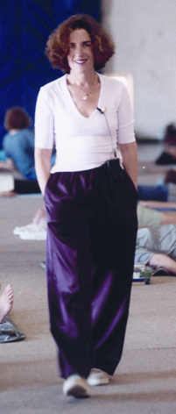
Anat Baniel
The discovery of movement developmental stages in humans is of great significance in trying to help children with developmental challenges. However, as so many therapists and parents have realized, trying to impose on a child to do what he/she is developmentally supposed to do often falls painfully short. When a child a few months old cannot roll over, for example, and other children of a similar age can do so easily, it is not only the rolling over that this child is missing, but a multitude of other movements, experiences and learning that the other children acquired before they began rolling over. When trying to directly simulate what the child “should” be doing, often times the child ends up practicing and learning failure. What needs to be recreated is the same process that leads healthy children to be successful learners.

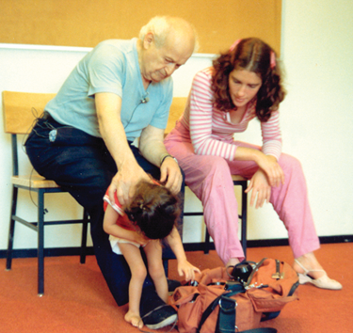
Since Grace’s parents live on the opposite coast, they try to bring her to me every 4-6 weeks for 6-8 lessons. During Grace’s second lesson series, as I put her on the table and started to move her gently, I realized she was already transformed by the first series of lessons. Rather than exert abrupt intense muscular efforts every time she tried to move, she attended instead to the feelings and sensations of her body while moving. At that point in the process her upper back and shoulders were very rounded and stiff. She had little use of her lower back, especially in relation to the movements of her arms and legs. Gradually and delicately I started moving Grace’s back, spine, ribs, sternum and shoulders in many different directions and configurations. As the freedom of movement in her back and hips increased, she was able to lighten the weight of her torso on the ground and began to crawl on her own.
Anat Baniel with
Dr. Feldenkrais in 1980

The gentleness with which the guiding movements are done and the insistence on having the child move in ways that feel easy and are not beyond the child’s true ability, creates a sense of safety for the child. This allows the child to feel him/herself and become aware of what he/she is doing and what is being done to them. As a result they become active, intelligent and happy learners just the way healthy children are. In fact, healthy children move –albeit spontaneously- in a great variety of ways that are easy and available to them. Portions from these movements get integrated by the brain into a useful action – for example crawling. Once a child accomplishes a milestone, it continues to generate a great variety of small and large movements from which the next milestone will be carved.

It is important to remember that it is the brain that controls movement and the quality of its organization. Spasticity and limitations in the musculature and skeleton are a manifestation of the workings of the brain. In this method we use movement and touch to communicate with the brain in ways that allow it to decipher how to organize movement effectively. With it comes immediate muscular, skeletal and often times mental and emotional improvement.

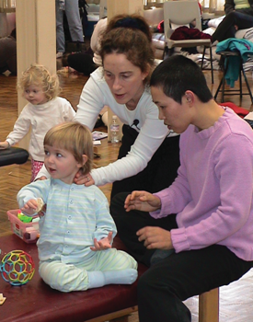
We* have now been working with Grace for two years. She has fully caught up to her age mentally and emotionally. Her back is mobile; she has almost complete freedom and control in her arm and hand movements. Her speech is clear; she spontaneously crawls on all fours; sits up sideways, cross legs, and “W” style. She comes to standing on her knees by pulling herself up. She transitions from one position to another fluidly and with great speed and precision. She is not yet able to stand up by herself. So at present we are introducing the next level of gentle movement variations from which she will carve the ability to stand.
Anat with Students in
Professional Training

* A team of three teachers currently share the work with Grace: Anat Baniel in California, Marcy Lindheimer in New York, and Bonnie Jokl in Atlanta.

Previously published in Cerebral Palsy Magazine, June 2003

©Copyright 2003, Anat Baniel Method^{sm}. All rights reserved.

